

FACULTY OF ENGINEERING AND TECHNOLOGY

**A REPORT ABOUT THE APPLICATION OF MATLAB PROGRAMMING FOR STRUCTURED DATA STORAGE, PROCESSING OF KAGGLE DATA SETS AND AUTOMATED EXPORTATION INTO MULTI-SHEET EXCELBOOKS**

COURSE UNIT: COMPUTER PROGRAMMING

LECTURER: Mr. MASERUKA BENEDICTO

SUBMITTED BY: GROUP 16

E-MAIL: [matlabgroup16@gmail.com](mailto:matlabgroup16@gmail.com)

*Submitted in partial fulfillment of the requirements of* COMPUTER PROGRAMMING

*DATE OF SUBMISSION.............../............../..............*

*SUBMITTED TO:**.......................................................*

# DECLARATION

We, the undersigned members of group 16, do hereby declare that this report is the result of our own work carried out in partial fulfillment of the requirements of this course.

**NAME SIGNATURE**



KABWERU ANDREW .............................



CHEMONGES MIKIRAR ........ .....................



NAGASHA RITTA ............ ..................



DIKITAL JOHN ............. .................

SANYU JOY ...............................

OULE SADOCK ............. ..................



WANGUSI DAVID .............. ..................

SEBATIKA COLLINE ................................



ATYANG MILDRED ..... ...........................

KITUTU LEONARD .................................

# APPROVAL

This report has been reviewed and approved by all group 16 members for submission. The work presented herein reflects our efforts and meets the requirements of the course.

Computer programming lecturer

Name: ......................................

Signature: ..................................

# ACKNOWLEDGEMENT

We, the members of group 16, would like to sincerely express our gratitude to our lecturer Mr. Maseruka Benedicto, for the guidance, support and encouragement offered to us throughout the course of this assignment. The knowledge and skills gained from module 1 to 4 were instrumental in enabling us to successfully complete the tasks.

We also extend our appreciation to all group members for their cooperation, commitment, and team work during the research, cording and report writing stages

Finally, we acknowledge the resources provided by Kaggle and the Matlab documentation, which helped us to accomplish the objectives of this work.

# DEDICATION

This report is dedicated to our families, friends and lecturers whose support, encouragement, and guidance have continually inspired us to work hard and pursue excellence in our studies.

We also dedicate it to our fellow students in group 16, whose team work, commitment, and collaboration made this report possible. Lastly, we dedicate this report to the pursuit of knowledge and academic growth, which remains the foundation of our future professional success.

# ABSTRACT

This report presents the work of group 16 on two Matlab programming tasks involving creating a structured variable to store members and their background information and also processing Kaggle datasets and exporting them into excel with each year on a separate sheet. The results demonstrated MATLAB’s usefulness in structured data, storage, dataset organisation and automated reporting

# LIST OF ACRONYMS/ ABBREVIATIONS

1. MATLAB – Matrix Laboratory
2. Struct – structure
3. i – imaginary unit

Table of Contents

DECLARATION ii

APPROVAL iii

ACKNOWLEDGEMENT iv

DEDICATION v

ABSTRACT vi

LIST OF ACRONYMS/ ABBREVIATIONS vii

CHAPTER ONE: INTRODUCTION 1

1.1 Background. 1

1.2 Historical Development 1

CHAPTER TWO: STUDY METHODOLOGY 2

2.1 Introduction 2

2.2 Steps followed 2

CHAPTER THREE: QUESTION ONE 3

3.1 introduction 3

3.2 Steps 3

3.3 Results 4

CHAPTER FOUR: QUESTION 2 5

4.1 Introduction: 5

4.2 Steps 5

4.3: Results. 6

CHAPTER FIVE: RECOMMENDATIONS AND CONCLUSION 8

5.1 Conclusion: 8

5.2 Recommendations: 8

CHAPTER SIX: REFERENCES 9

APPENDICES 10

# CHAPTER ONE: INTRODUCTION

## 1.1 Background.

MATLAB, which stands for matrix laboratory, is a high-performance programming language and environment designed primarily for technical computing. Its origins trace back to the late 1970s when Cleve Moler, a professor of computer science, developed it to provide his students with easy access to mathematical software libraries without requiring them to learn Fortran.

## 1.2 Historical Development

* + Initial Development: The first version of MATLAB was created in Fortran in the late 1970s as a simple interactive matrix calculator. This early iteration included basic matrix operations and was built on top of two significant mathematical libraries: LINPACK and EISPACK, which were developed for numerical linear algebra and eigenvalue problems, respectively.
  + Commercial Launch: MATLAB was officially launched as a commercial product in 1984 by MathWorks, a company founded by Moler along with Jack Little and Steve Bangert. This marked the transition from a simple calculator to a comprehensive programming environment. The software was reimplemented in C, enhancing its capabilities with the addition of user-defined functions, toolboxes, and graphical interfaces.
  + Expansion and Toolboxes: Over the years, MATLAB has expanded significantly. By the late 1980s, it had introduced several specialized toolboxes for various applications, including control systems and signal processing. The introduction of the Simulink environment further allowed users to model and simulate dynamic systems graphically.
  + Modern Enhancements: Recent versions of MATLAB have introduced features like the Live Editor, which allows users to create interactive documents that combine code, output, and formatted text. This evolution reflects MATLAB's ongoing adaptation to meet the needs of its diverse user base across academia and industry.

# CHAPTER TWO: STUDY METHODOLOGY

## 2.1 Introduction

the study coverage adopted for this repot involved a systematic approach to analysing and visualising the given data for question 1 & 2 following the steps below;

## 2.2 Steps followed

* **Data collection and preparation**

We obtained data from the provided sources, including Excel files containing various parameters.

We then cleaned the data cleaned to remove inconsistencies and organized for analysis.

* **Data Analysis**

Computational tools such as MATLAB were used to analyse the data.

Statistical methods and mathematical models were applied to identify trends, patterns, and relationships among the variables.

* **Visualization**

Different plots, graphs, and charts were generated to visually represent the findings.

Each visualization was annotated and labelled for clarity and better interpretation.

* **Interpretation**

Results were interpreted in the context of the study objectives.

Observed patterns and relationships were discussed to draw meaningful conclusions.

* **Documentation**

All codes, plots, and findings were systematically documented and saved for reference.

The report was compiled in a structured format to ensure readability and coherence.

# CHAPTER THREE: QUESTION ONE

## 3.1 introduction

Question 1 required us to retrieve a unique dataset from Kaggle.com in excel format and then generate a Matlab code that would copy variables of each year, put them in tables for each year convert the tables into struct arrays and output each of the variables into a single workbook with each year on a separate sheet

## 3.2 Steps

**Step 1: downloading excel file**

We accessed ***kaggle.com***, signed up and managed to download a unique data set in excel named “*sales_data.CSV”*

**Step 2: reading the excel file into Matlab.**

using the MATLAB’s inbuilt function “*readtables*”, we managed to read the excel file into Matlab and named the variable as data



**Step 3: converting Date column format to datetime(dd/mm/yyyy).**

Using datetime function, we changed the Date column format sine it was going to help us in the next step.



**Step 4: creating a column for year.**

we then created a column for years labelled “*Year*”.



**Step 5: finding unique years in the data**

Using the unique function “unique”, we succeeded in finding unique years in the data



**Step 6: looping through each year, creating a table and struct.**

Using Matlab functions such as “*struct”, “i”, “for”,* “writetable” and *“sprintf”,* we created a structure named *“yearly struct”*, looped through each year, stored the data as a struct and then wrote the data into an excel workbook named “*yearly_data.xlsx*” with each year on separate sheets

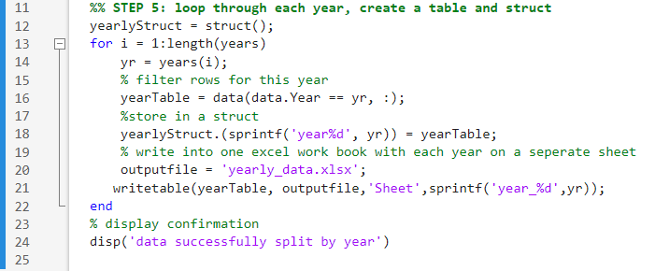

## 3.3 Results

After running the code, it produced the following outputs;

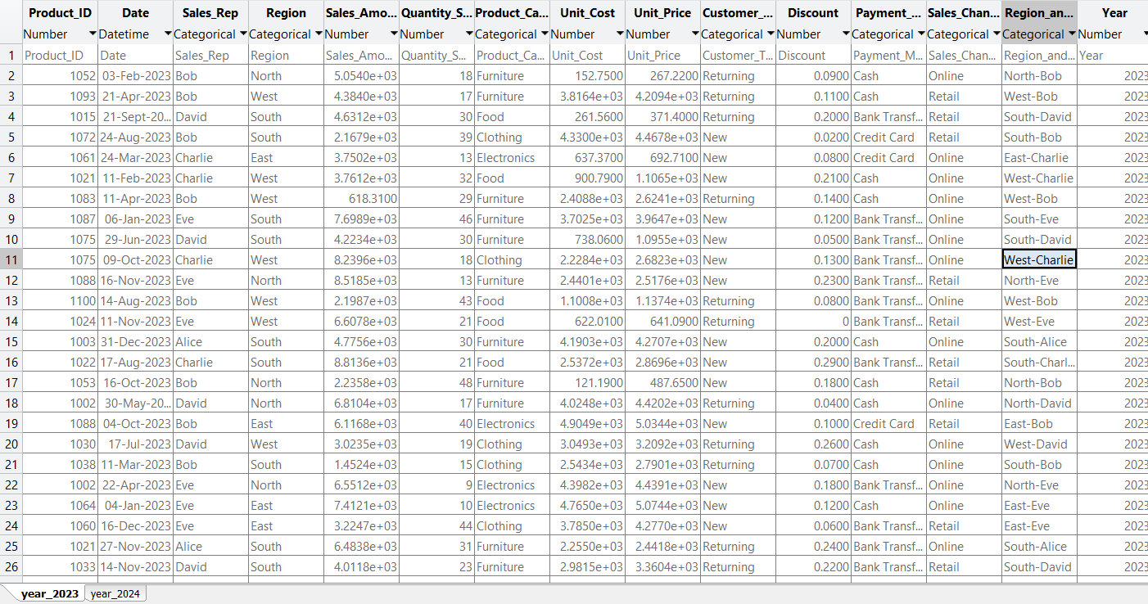

# CHAPTER FOUR: QUESTION 2

## 4.1 Introduction:

Question 2 required us to write a Matlab code that can store each members affirmation attributes into a single variable and it saves the variable

## 4.2 Steps

**Step 1: identifying and understanding the attributes.**

From the question we were required to assign individuals the following attributes;

Name, Home District, Religion, Course, Tribe, Village, Interest, Facial representation.

**Step 2: deciding on the best Matlab data structure**

Basing on the research we carried out from various web sites, we decided to use “*array of* *structures”* as our Matlab data structure

**Step 3: defining the structure**

Using Matlab inbuilt function struct, we defined the struct and assigned it a variable name *“Student”*

**

**Step 4: writing Matlab code**

We the initialised the structure and stored each members details in it

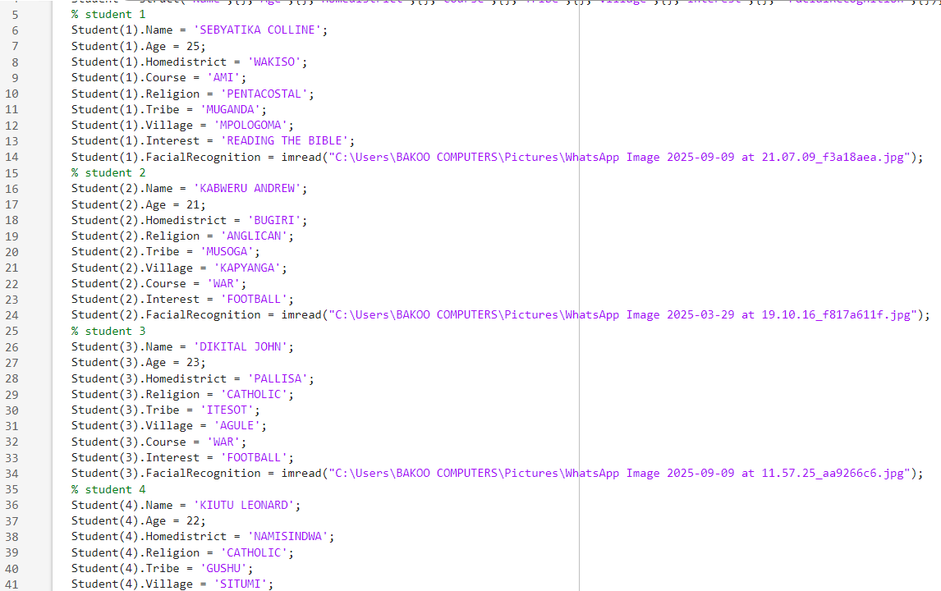

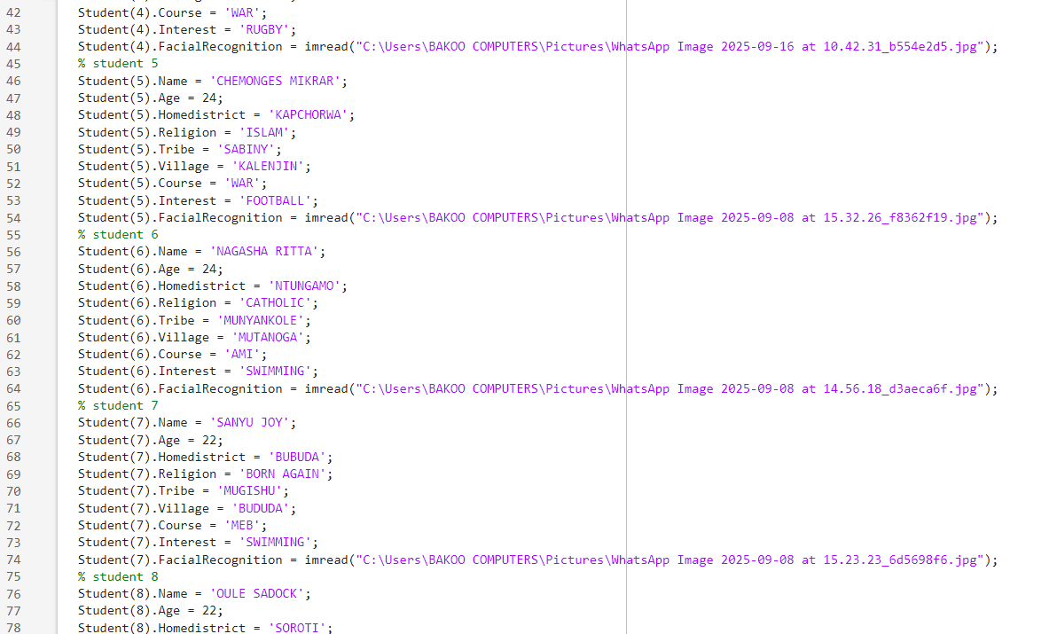

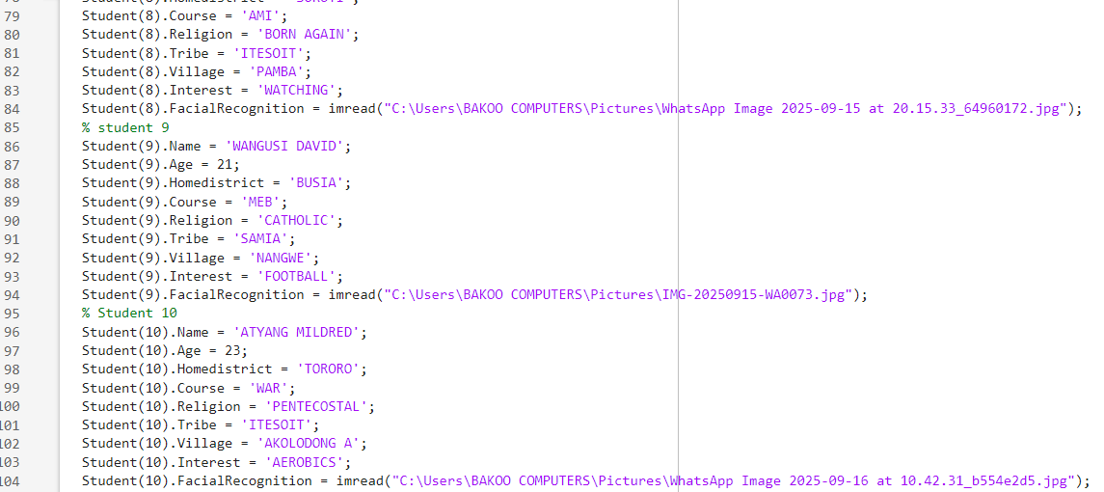

**Step 5: saving the variable.**

Using the save function, we saved the variable as *“Students.mat”*

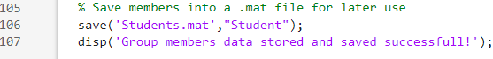

## 4.3: Results.

After running the above code, we obtained the following output

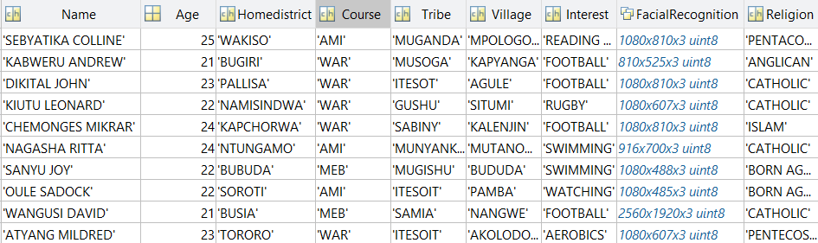

# CHAPTER FIVE: RECOMMENDATIONS AND CONCLUSION

## 5.1 Conclusion:

The study achieved its objectives by analysing the data and presenting meaningful results. The findings highlighted key patterns and demonstrated the importance of teamwork and systematic approaches in producing reliable outcomes.

## 5.2 Recommendations:

* Furtherattention should be given to improve data collection and analysis methods in order to ensure more accurate results.
* Group members should continue collaborating closely, as team work played a key role in the success of this assignment
* Clear documentation and systematic reporting should always be maintained to enhance understand, reproducibility, and practical application of the results.

# CHAPTER SIX: REFERENCES

* MATLAB Documentation: <https://www.mathworks.com/help/matlab>
* course Lecture notes (module 1 – 4)

# APPENDICES

